import sqlite3

conn = sqlite3.connect('Student_Database')

print ("Opened student database successfully");

conn.execute('''CREATE TABLE Registration

(ID INT PRIMARY KEY NOT NULL,

NAME TEXT,

AGE INT,

ADDRESS CHAR(10),

PROGRAM TEXT,

EMAIL TEXT,

PHONE INT(10));''');

print ("Table created for student database successfully");

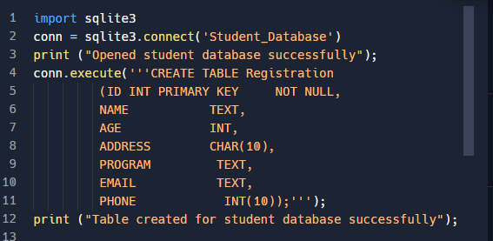

conn.execute("INSERT INTO Registration (ID, NAME, AGE, ADDRESS, PROGRAM, EMAIL, PHONE) \

VALUES (1, 'Pritha', 28, 'kolkata', 'MBA', 'na@na.com', 8013361542 )");

conn.execute("INSERT INTO Registration (ID, NAME, AGE, ADDRESS, PROGRAM, EMAIL, PHONE) \

VALUES (2, 'Bikram', 32, 'Siliguri', 'DevOps', 'na@na.com', 9832592492 )");

conn.execute("INSERT INTO Registration (ID, NAME, AGE, ADDRESS, PROGRAM, EMAIL, PHONE) \

VALUES (3, 'Priyanka', 28, 'Kolkata', 'MBA', 'na@na.com', 0000000000 )");

conn.execute("INSERT INTO Registration (ID, NAME, AGE, ADDRESS, PROGRAM, EMAIL, PHONE) \

VALUES (4, 'John', 30, 'Kolkata', 'MBA', 'na@na.com', 0000000000 )");

conn.execute("INSERT INTO Registration (ID, NAME, AGE, ADDRESS, PROGRAM, EMAIL, PHONE) \

VALUES (5, 'Ramen', 30, 'Kolkata', 'MBA', 'na@na.com', 0000000000 )");

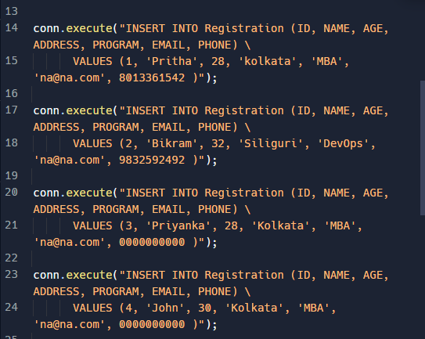

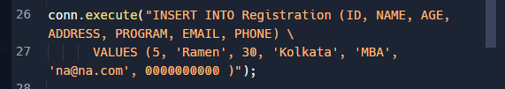

conn.commit()

print ("Records created for student database successfully");

cursor = conn.execute("SELECT ID, NAME, AGE, ADDRESS, PROGRAM, EMAIL, PHONE FROM Registration")

for row in cursor:

print ("ID = ", row[0])

print ("NAME = ", row[1])

print ("AGE = ", row[2])

print ("ADDRESS = ", row[3])

print ("PROGRAM = ", row[4])

print ("EMAIL = ", row[5])

print ("PHONE = ", row[6]);

print ("Operation for student database done successfully");

conn.close()

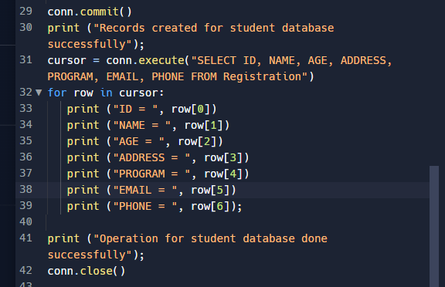

Reference link :

<https://replit.com/languages/python3>

<https://www.online-python.com/>

**Expected Output**

